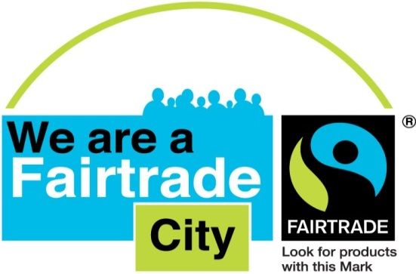

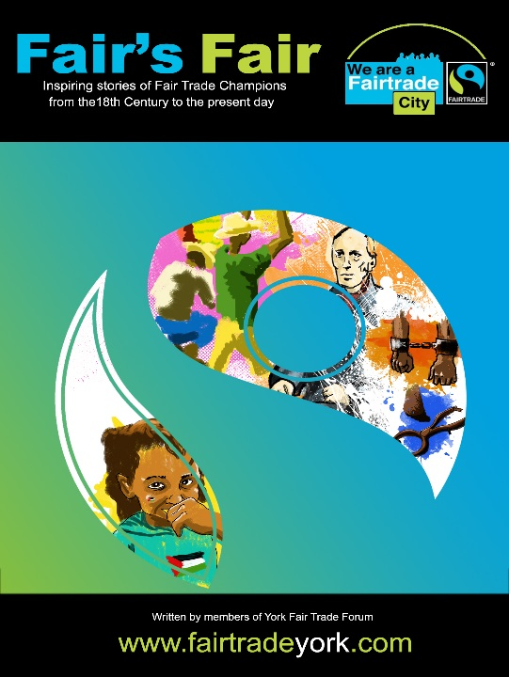***Fair’s Fair* Teaching Notes**

Introduction

We have not endeavoured to link these teaching notes to any of the (ever-changing) curriculum requirements, or to specify any particular age range, although some suggestions are clearly for older or younger pupils. We believe teachers to be more than capable of deciding which activities are most appropriate to their own classes and adapting ideas as appropriate. These suggestions are merely a guide for how teachers may want to explore Fair Trade, fairness and justice issues further, and to immerse pupils more fully in the concepts and questions that are raised by the stories. Sensitivity may be necessary when dealing with some of the more contemporary stories, (for example Palestinian olives), if pupils have had difficult experiences or may relate personally to the people, places or events described. We hope you and your pupils will have enjoyable and thought-provoking learning experiences and we would love to share in them! Find out if you have a Fair Trade group in your town or city and invite them into school to talk about an aspect of Fair Trade.

We would be delighted to receive any feedback or suggestions, or feature photographs of your *Fair’s Fair* activities on the York Fair Trade Forum website (http://www.fairtradeyork.com). You can email us on **helen@fairtradeyork.com.**

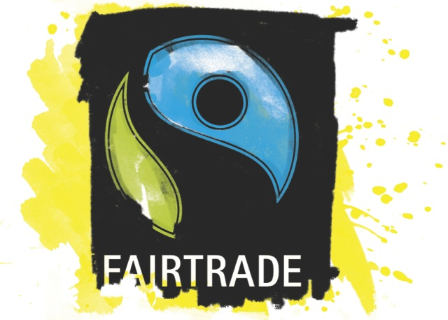

**Ideas to get you started**

* Work in small groups to explore and discuss the meaning of ‘fairness’. Present ideas to the rest of the class, and choose a set of definitions on which the class can agree. Do the pupils all agree that it is important to treat people fairly? Is it still as important when we are referring to people we will never meet?
* Read about Sami and the products she looked at in the Introduction. What questions would you like to ask the people who produced these items? How might their lives be different from, or the same as, your own? Use the Fairtrade Foundation website, [www.fairtrade.org.uk](http://www.fairtrade.org.uk), Oxfam website [www.oxfam.org.uk](http://www.oxfam.org.uk), Think Global website <https://globaldimension.org.uk/resources/search/?fwp_topic=fair-trade> and Global Teaching websites such as <http://www.centreforglobaleducation.org/> for ideas and resources.
* Look at the labels on products you have in your own home (with parental consent/help as necessary). How many countries of origin can you find? Which products could and could not be produced in the UK? Does it matter where our food comes from or how it gets to us…why?
* Look at the places featured in all of the stories; find and plot them on a World Map and display. (The Peters Projection is a very good world map, which shows all the countries in correct relative size to each other. You may be surprised how small Europe looks compared to Africa on this projection!) Use atlases to find out further information about these countries and compare to the UK, perhaps by making graphs or tally charts.
* Have a Fair Trade Day at your school to showcase some of the work you have done; this could include a Fairtrade café, football activities and games with Fairtrade footballs, Fairtrade recipes, a food tasting – chocolate tasting is always popular. Invite a local Fair Trader to run a Fairtrade pop-up shop at the event – your local Fair Trade group can help with this.
* If you can, visit York and walk the Fair Trade Trail, to investigate places which sell Fairtrade in the City Centre and talk to the traders. Maybe you can develop a Trail in your own town.
* Watch the short films on the Fairtrade Foundation website to find out more about the lives of producers around the world and the difference Fairtrade makes to their ability to make a living. <http://www.fairtrade.org.uk/en/resources-library>

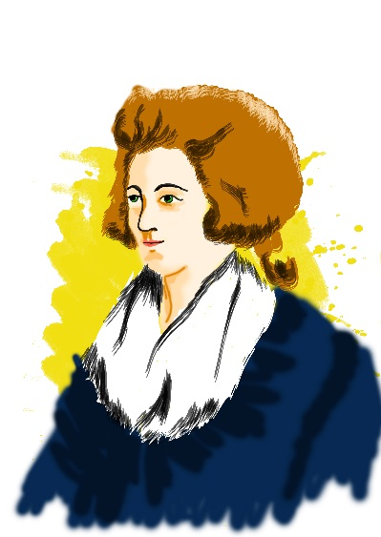

**When Sugar was Not so Sweet – Hannah More**

* Imagine being a young girl in Hannah’s time. What do you think it would have been like when boys and girls were brought up so differently? Do you think it was fair? How and why do you think things have changed? Find out about the Bluestockings and how they challenged unfair treatment of women and girls.
* Look at excerpts from Hannah’s poem ‘Slavery’ and choose a section to illustrate. Have a look at her portrait too. What sort of a person do you think Hannah might have been? Make a collection of words and phrases to describe her. <http://www.poetryfoundation.org/poems-and-poets/poems/detail/51885> <http://www.poetryfoundation.org/poems-and-poets/poets/detail/hannah-more>
* Consider the idea of ‘blood sugar’ and compare to the modern problems of ‘blood diamonds’ and ‘blood minerals’, where the minerals produced by bonded labourers and slaves is being used to prop up corrupt regimes and finance conflicts.
* Find out about William Wilberforce and the Anti-Slavery movement with which Hannah was involved.

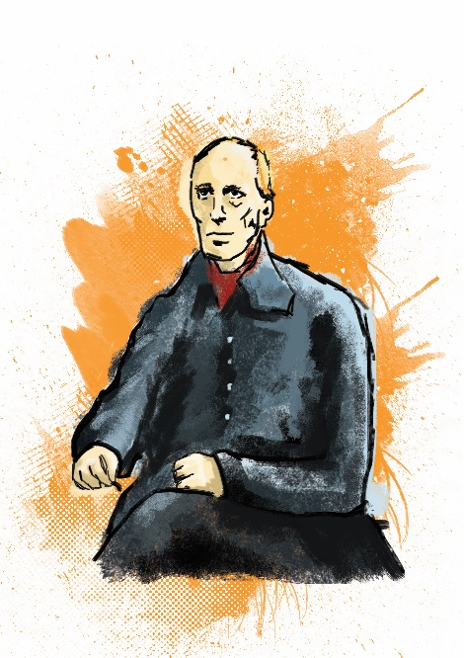

**The Story of Levi Coffin**

* Find out about the Quaker Movement, now called the Society of Friends, and how their beliefs strongly affect the way they live their lives. If there is a Friends’ Meeting House near you, arrange a visit.
* Consider the fact that Quaker families like Levi’s often sheltered runaway slaves and helped them escape. Make collections of words and phrases to express the feelings of the runaway, or of the person sheltering them. What hopes and fears would each of them have, and what problems might they have to face? Use your collections to write and illustrate a story or write and perform a play about a family like Levi’s, sheltering and helping a runaway slave.
* Levi Coffin is described as an early example of a Fair Trade retailer, because he would not stock goods produced by slaves. Invite a modern day Fair Trade retailer to come in and talk to the class about what they do and why they do it. How can we make sure our purchases are not supporting slavery today?
* Contact the Centre for Global Education in York <http://www.centreforglobaleducation.org/> and ask if you can borrow the exhibition Free at Last? and the book of teaching ideas which explores the history of Slavery, including modern day slavery.
* **RESOURCES ON SLAVERY IN THE PAST AND TODAY**

|  |  |  |
| --- | --- | --- |
| **Story Books** | **Description** | **Suitable for** |
| Aunt Harriet’s Underground Railroad in the Sky | Story of discovery by two children of their ancestors’ journey from slavery to freedom | Primary |
| The Silent Witness | A True Story of The Civil War | Primary |
| Almost to Freedom | Story about a girl and her family who flee the cotton fields of Southern USA | Primary |
| Only Passing Through | The Story of Sojourner Truth, a slave in the 1800s | Ages 7-10 |
| Sweet Clara and the Freedom Quilt | Story about a slave in the cotton fields of Southern USA | Key Stage 2 |
| Under the Quilt of Night | Story of escape to freedom by slaves | Key Stage 2 |
| President of the Underground Railroad | A Story about Levi Coffin | Primary / Secondary |
| **Non-Fiction Books** |  |  |
| The Life of Harriet Tubman | The biography of a slave in the 1800s | Primary |
| ‘Follow the Drinking Gourd’ | By Jeanette Winter, (Dragonfly Books, 1992), ISBN 0-679-81997-5. This book starts with a brief historical introduction. | Primary |
| ‘Wanted Dead or Alive’: | The True Story of Harriet Tubman  Ann McGovern, Richard M. Powers (Illustrator), R.M. Powers (Illustrator) (Scholastic Paperbacks 1991), ISBN: 0590442120,. | Primary |
| Harriet Tubman: Conductor on the Underground Railroad’ | By Ann Petry (Harper Trophy 1996), ISBN: 0064461815 (256 pages) | Primary |

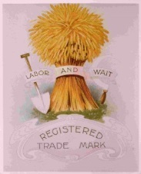

**Working together –**

**The Rochdale Pioneers**

* Read the story and then decide what would your ‘Rochdale Principles’ be? Devise a set of rules to enhance fairness in your class or school, or even for your town or city.
* Set up a class ‘shop’ (using tokens or plastic money and ‘selling’ small items), to help the pupils understand how a Co-operative works. Calculate each person’s ‘divi’ depending on what they have spent – good practice for percentages!
* Visit the Co-operative website or your local Co-op store, or invite the local Co-op manager in to school. Find out if the early principles of fairness still apply today and why.
* Watch the 2012 film *The Rochdale Pioneers*, available on DVD from the Rochdale Pioneers Museum shop: <http://www.rochdalepioneersmuseum.coop/product/rochdale-pioneers-dvd-2/>
* Why do you think the other traders in the town were so against the Pioneers to begin with? Set up a debate between the two sides, to explore the issues from both points of view.
* Look at the Rochdale Pioneers ‘Wheatsheaf’ poster. Can you design a poster of your own, with a symbol to represent and encourage co-operation?
* If you are near enough, visit the Pioneers Museum in Rochdale – an excellent and thought-provoking place to see.

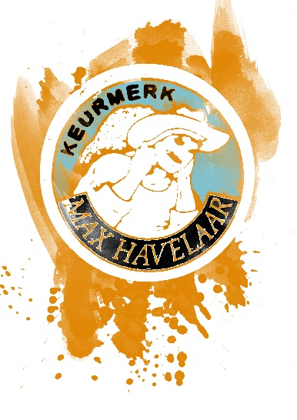

**The Aroma of Fairtrade Coffee**

* Nico Roozen and Frans van der Hoff met by chance in a railway station and got chatting – and the first Fairtrade Mark was the result. Can you imagine how they got talking? Work in pairs and have a conversation, pretending you have never met before. Have a go at writing together what that first conversation might have sounded like.
* The two men chose ‘Max Havelaar’ as the name for their Fairtrade label; because he was a fictional character all Dutch people had heard of, who stood up for fairness. His creator, 19th century author, E.D. Dekker, was also a campaigner against unfair treatment. Which well-known fictional character might you pick as a good example of fairness, and why? Can you design a label to go with him or her? Find out about authors and other creative people today who stand up for those being treated unfairly. (For example, the poet Ian McMillan, who is mentioned in the final story).
* Find out what Nico and Frans have been doing since Max Havelaar was set up. Write a short biography or make a time line for one of them, showing their achievements for Fair Trade.

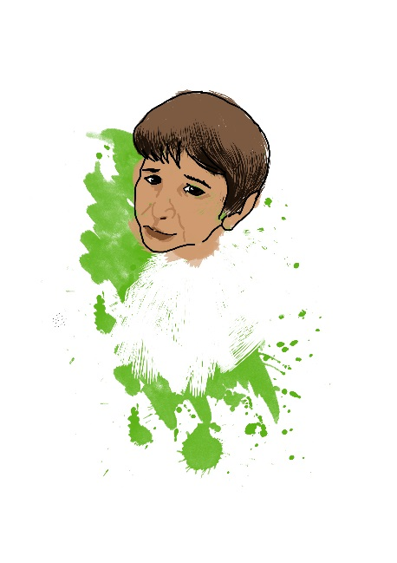**Iqbal Masih, Kailash Satyarthi and**

**The Goodweave Label**

* Before reading the story to the class, take them into the hall or the playground. Ask the pupils to get into a squatting position. Are they comfortable in this position? Now ask them to begin miming tying lots of little fiddly knots with their fingers. Ask them to look closely at what they are ‘doing’ and concentrate on the knots. Are they still comfortable? Who feels like they need to get up and stretch yet? Who is finding their neck feeling a bit uncomfortable, looking down all the time? Maybe some of the children have already moved out of position. Now read the first paragraph of the story and ask them to imagine Iqbal, from age 4 to age 10, being in this position for hours and hours every day, and being punished if he did not continue working at all times. Have a discussion about how Iqbal ended up having to do this. What is the problem and how can it be prevented? (Help the class to see that it is the unfair working practices, social pressures and inequality of income that is the problem, not Iqbal’s parents.) Read the rest of the story which shows how Iqbal escaped and became an activist, working alongside people like Kailash Sathyarti, to change the law to prevent child and bonded labour, and to enable people to earn a living without having to consider sending their young children out to work. Find out more about the Goodweave mark at <http://goodweave.org/home.php>
* Reflect on the fact that Iqbal used his childhood experiences positively and became an advocate for better working practices, rather than trying to take revenge on the people who had made his young life so miserable. Why do you think he did this?
* Look up Kailash Satyarthi <http://www.kailashsatyarthi.net/> He won the Nobel Peace Prize jointly with Malala Yousafzai in 2014 for their work on children’s rights, and their campaigning to get children out of forced labour and into education. Their collaboration is regarded as ground-breaking because Malala is a Pakistani Muslim and Kailash is an Indian Hindu.
* Find out about rug designs from different cultures, and what a skilled job rug making is. Design, draw, paint or even weave your own simple rug designs.
* Explore the problems of child labour and bonded labour throughout manufacturing in the majority world. Which organisations are addressing this issue and are they having success? Watch the excellent new Fairtrade Foundation short film about Fairtrade football manufacture: <http://schools.fairtrade.org.uk/resource/football/> Could your school or local club buy Fairtrade footballs next time new stock is needed, and help bring an end to bonded labour in this area of manufacturing?

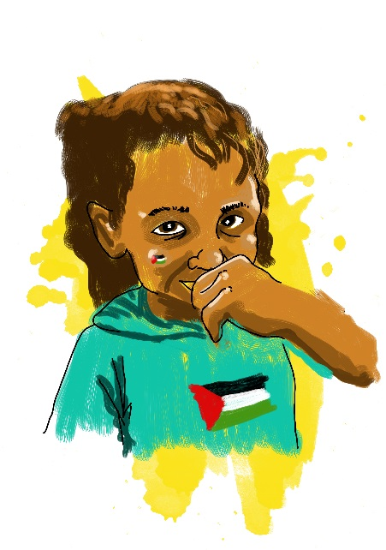**Zaytoun – Arabic for Olive**

* Look at the opening proverb, which describes olives as ‘constant’. Look up the definition and consider why olives are regarded as constant. To enable the pupils to appreciate the longevity of an ancient Palestinian olive tree, make a time line or ‘time machine’, to highlight some of the historical events the olive tree has lived through, right back to the Romans and the time of Christ. (This is a good way to revisit and consolidate all the history topics so far covered!) If appropriate in your setting, look up references to olive trees in the Bible, Qur’an and Torah, and the olive as a symbol of peace in different religious stories.
* The story mentions the way the olive groves enable Palestinians to feel ‘attached’ to the land. Explore in groups and as a class, what makes the children feel ‘attached’ to where they live and gives them a sense of place. Pupils could work in groups to make a map of their area with significant places marked. How would they feel if their special places were under threat, or they were not allowed to go to them any more? This may be a sensitive discussion if you have Asylum- seeker or Refugee children in your class.
* Buy and try some Zaytoun products, maybe, if you are near York, from Fairer World in York, one of the first shops to stock Zaytoun in the UK: <http://www.fairerworldyork.co.uk/> . Your local Fair Trade shop may also stock these items. Dip cubes of bread into the olive oil to sample the taste, and find out about its many uses – medicinal, culinary and household. Try making some traditional Palestinian recipes, or if appropriate in your setting, hold a bring-and-share food event with food from the different cultures represented in your community.



**Blooming Unfair**

* Design a poster to advertise Fairtrade flowers, expressing the beauty of the Fairtrade Premium to flower farming communities alongside the beauty of the flowers they grow. Work in groups to develop a catchy slogan to encourage shoppers to purchase Fairtrade flowers.
* Can you find Fairtrade flowers in your local shops? The class could write to appropriate local outlets and ask them to stock Fairtrade flowers in time for a suitable celebration, such as Mothering Sunday, Carnival or a local ‘In Bloom’ event.
* Compare the problems of the non-Fairtrade flower farmers with those who benefit from being part of the Fairtrade system. Write a short dialogue or play where two different flower farmers compare their working lives.
* Make a set of Working Conditions cards for the class to sort, using the story, into ‘before’ and ‘after’ a flower farm becomes Fairtrade. Compare these conditions with working rights in the UK and other developed countries.
* The story makes clear that water scarcity and water pollution is a huge challenge in the Lake Naivasha area of Kenya. Explore how water is being overused in other parts of the world too – Australia, California, the Aral Sea – to illustrate that this is not just a problem for the poorest; but that if an area is poor then it is a much harder problem to manage due to weaker infrastructure, poorer healthcare and more vulnerable people.

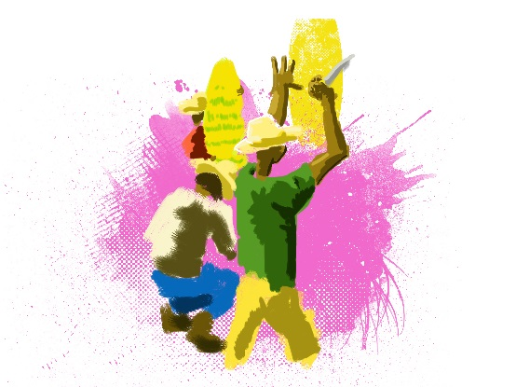**Producing bananas in Colombia**

* Collect data in the class about bananas – who likes them, who prefers them ripe or unripe, how many bananas does the class/school eat in a day or in a week, etc. and create a Banana Data Handling display.
* Visit local supermarkets to find out which ones stock Fairtrade bananas – and which ones ONLY stock Fairtrade bananas. If you don’t find any, write letters to ask your local shop to stock them. Write to your Council or your school’s catering company, to find out if you can get Fairtrade bananas as part of your school fruit delivery. Ask your local paper to report on your campaign.
* Try different banana and plantain recipes. Make a class recipe book of banana recipes. Could you eat them every day, like Aimeth does?
* Have a Yellow Day to celebrate all things banana; perhaps to coincide with Fairtrade Fortnight (see http://www.fairtrade.org.uk/en/get-involved/events) or World Fair Trade Day (the second Saturday in May – see http://wfto.com/events). Invite the parents and community to come and take part.
* Find out more about Aimeth’s job – what are ‘Quality Management Systems’ and why they are important in business? Explore the problems Aimeth and her community might face, with climate change and the massive growth of palm oil plantations, and how these problems can be addressed, locally and nationally, in banana-growing areas like Colombia.

**Founding the Fairtrade Town movement**

* Consider how the Fairtrade Town movement began. How did Bruce and his friends make their great idea happen? What characteristics did they need to inspire and motivate a whole town of people? What difficulties do you think they may have had along the way? How do you think they overcame them?
* Visit the FIG Tree website, <http://fairtradecentre.org/> , to find out what they do. **The FIG** **Tree is currently not operating from St. John’s Church in Lancaster, due to flooding. St. Nics Arcade hosts a stall in the Arcade on Wednesdays and Saturdays and Lancaster Friends Meeting House is used for workshops, meetings and events.** Also try walking the Lancaster Fair Trade and Slavery Trail – contact the FIG Tree for more details about the walk.
* The FIG Tree do various excellent educational workshops both on site and in schools in the North; see <http://fairtradecentre.org/workshops-2/educational/> for details.

**Making Yorkshire the first Fairtrade Region in the UK**

* Mark, like Bruce in the previous story and some of the people in earlier stories, is a campaigner and activist. Find out what those words mean and what characteristics campaigners and activists may have, to enable them to do their work. Look at issues in current affairs, in the UK and abroad, where people are currently campaigning. Is it something people choose to do, or do they feel they have to do it? What makes it difficult or controversial? What would make you become a campaigner? Find out about campaigners of our time, famous and not so well-known, and make a booklet about some of the ones you particularly admire. Do you think it is important to have campaigners in our society…why?
* Explore the Fairtrade Yorkshire website at <http://www.fairtradeyorkshire.org.uk/> and find out what Fairtrade campaigners across the region have been doing recently to promote Fair Trade of all kinds. If you are a Yorkshire school, consider how you could get involved.

Teaching notes written by Helen Harrison for York Fair Trade Forum to accompany Fair’s Fair, a 21-page book available from the Forum. See details at <http://www.fairtradeyork.com>. You can also buy the book from other outlets including Fairer World, Shared Earth and Spurriergate Centre (all in York), Aroma café (Haxby, York) and All’s Fair (Selby).

